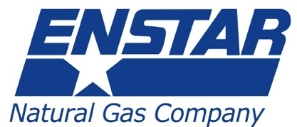

5151 Fairbanks Street
P.O. Box 190288
Anchorage, AK 99519-0288
www.enstarnaturalgas.com

[Date]

[First name, Last name]
[Account mailing address]

[First name, last name]

We are writing to inform you of planned work to replace aging natural gas pipelines along the Spur Highway from Bridge Access Road to Candlelight Drive. Our records indicate that you have an ENSTAR account address located within this impacted area, which includes:
- Walker Lane and the Central Heights subdivision
- Lawton Drive and the Inlet View subdivision
- Kenai High and Middle School
- Neighborhoods between N. Tinker Lane and Candlelight Drive
- McCollum and Aliak Drive

ENSTAR Gas Line Replacement Project

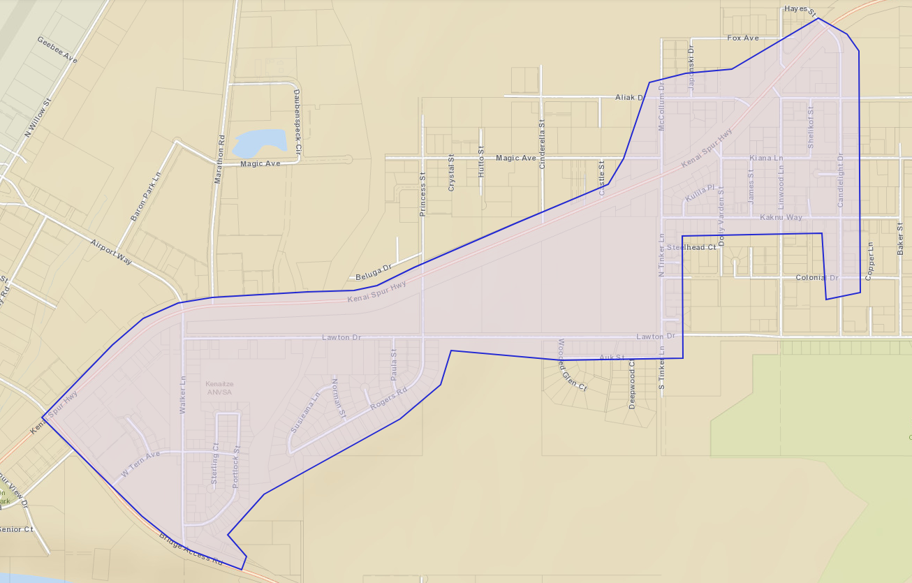

The purpose of the project is to replace aging natural gas pipelines that are approaching 70 years. Aging pipelines are susceptible to leaks and damage from earthquakes and freezing/thawing ground. We are replacing these pipelines to make sure we continue to provide safe and reliable natural gas service for decades to come.

The work will happen in two main phases:

- End of April – May 2026: ENSTAR will begin moving gas meters to ensure they are properly located and fitted to connect to the new piping. In some cases, we will replace meters. If your meter is moved or replaced, you will receive a door tag indicating ENSTAR was at your property to perform work.
- Mid-May – Early August 2026: Construction work to replace existing piping. While we do not anticipate road closures, traffic may be congested at times. During this period, please refrain from parking on the street. This ensures that our crews work as quickly as possible and avoid prolonged disruption in the area.
- You may also notice ENSTAR work in or around your yard to replace service lines that feed gas from the natural gas “main” pipeline to your meter. Any disturbed ground will be restored and reseeded as needed to return the property to its previous condition.

What to expect:
You will likely notice ENSTAR and contractor vehicles in the construction area. These vehicles can include trucks, vans, excavators, dump trucks, and trailers. You may also observe contractors working in the area on ENSTAR’s behalf. Individuals working on your property will be ENSTAR employees or the employees of an ENSTAR contractor. You can identify these employees by the ENSTAR logo on their hats, shirts, and/or safety vests. If you ever question the identity of someone representing themselves as an ENSTAR employee, give us a call at 262-9334.

For more information and project updates, visit: www.enstarnaturalgas.com/kenai.

Thank you for your patience during this project to replace aging infrastructure. We apologize for any inconvenience you may experience during this work. As always, our number one priority is to provide you with safe and reliable natural gas service. This project, along with your support, helps us deliver on that goal.

Sincerely,

Nathan Burke
Manager of Infrastructure Planning
ENSTAR Natural Gas Company
Nathan.burke@enstarnaturalgas.com

